Setup Office 365 Email Account on Smart Phone

Apple iPhone
- Tap Settings > Mail, Contacts, Calendars > Accounts > Add account > Email.
- In the Add Account page, tap Exchange.
- Enter your full email address, for example tony@contoso.com, and your password, and then tap Next.
If the device can't find your settings, you need to add them. If you have an Office 365 Exchanged email account in Server, enter outlook.office365.com, and then add your Username and Password. This is the same username and password you use for work or school.
- By default, Mail, Contacts, and Calendar information are synchronized. Tap Save.
- If you're prompted to create a passcode, tap Continue and type a numeric passcode. If you're prompted and don't set up a passcode, you can't view this account on your device. You can also set up a passcode later in your settings.
Note If you get a time-out message, your password or other information might be incorrect. Retype the information, and then try again.
Android
- Tap Settings > Accounts > Add account > Email. This application might be named Mail on some versions of Android.
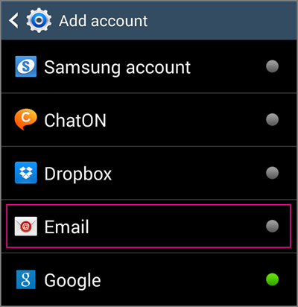
- Type your full email address, for example tony@contoso.com, type your password, and then tap Next.
- Select Exchange.
- If prompted, accept the defaults on the Exchange server settings page, and tap Next. If your device can't connect, enter the following account information, and then select Next.
  - Domain\Username Type your full email address in this box, for example, tony@contoso.com. If Domain and Username are separate text boxes in your version of Android, leave the Domain box empty, and type your full email address in the Username box.
  - Password Use the password that you use to access your account.
  - Exchange Server Use the address of your Exchange server. If you aren't sure what your server address is, check with your administrator.
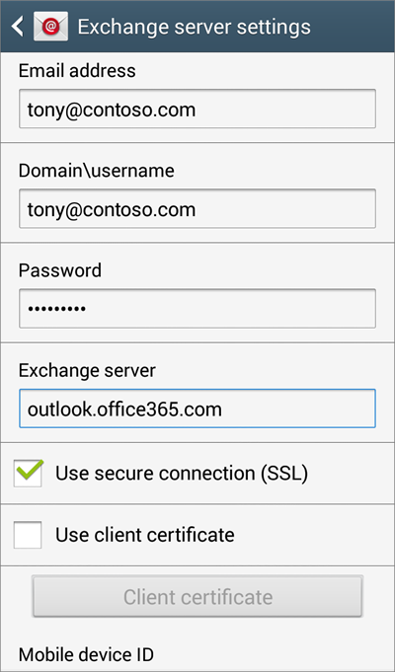
  - Depending how your Exchange administrator set up your account, you might receive a message about additional security features. Select OK to continue.
- As soon as the device verifies the server settings, the Account Options page opens. Select the options for how you want to receive your mail, and then tap Next. (You may need to scroll down to see Next.)
- If you see Activate device administrator? page, select Activate.
- Give the account a name, and then tap Done.

