Setup Desktop Outlook to Connect to Office 365

- Open Outlook 2013 or Outlook 2010. When the Outlook Startup Wizard opens, select Next. On the E-mail Accounts page, select Next.
If the Wizard didn't open or you want to add an additional email account, on the Outlook toolbar select the File tab.
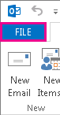
- Select Add Account.
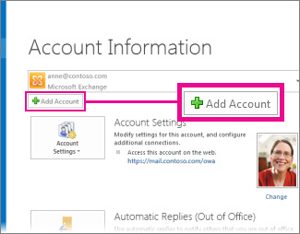
- On the Auto Account Setup page, enter your name, e-mail address, and password, and then select Next.
- Select Finish.

